PHASE 4 – Creating a Record Producer
Create a Record Producer that allows employees to submit Employee Raise Issue requests through the Service Portal and automatically create records in the custom table.

Creating the Record Producer
1. Navigate to All menus → Service Catalog → Catalog Definition → Record Producers.
2. Click New.
3. Name: Raise Employee Issue.
4. Table: Employee Raise Issue.
5. Enter an appropriate description in What it will contain.
6. In Accessibility, select Catalog: Service Catalog and Category: Service.
7. Upload an image in the Picture field.
8. Set the Meta name to the table name.
9. Save the form.

Creating Variables
- Under Related Links → Variables, click New.
Create variables and enable Map to Field so each variable populates the corresponding target-table field. Use orders such as 100, 200, 300, etc.

Variable Configuration
What is the Requester name — Reference — sys_user
Which Category — Choice — Network, Software, Hardware, Access
What is Subcategory — Choice — VPN, Laptop, Server, Forgot password
Which State is this issue — Choice — New, In progress, Resolved, Closed
Short description — Single Line Text

Service Portal Verification
Open the Service Portal URL and add the suffix /sp. Search for the table/record producer to verify that the producer is available.
Record Producer form
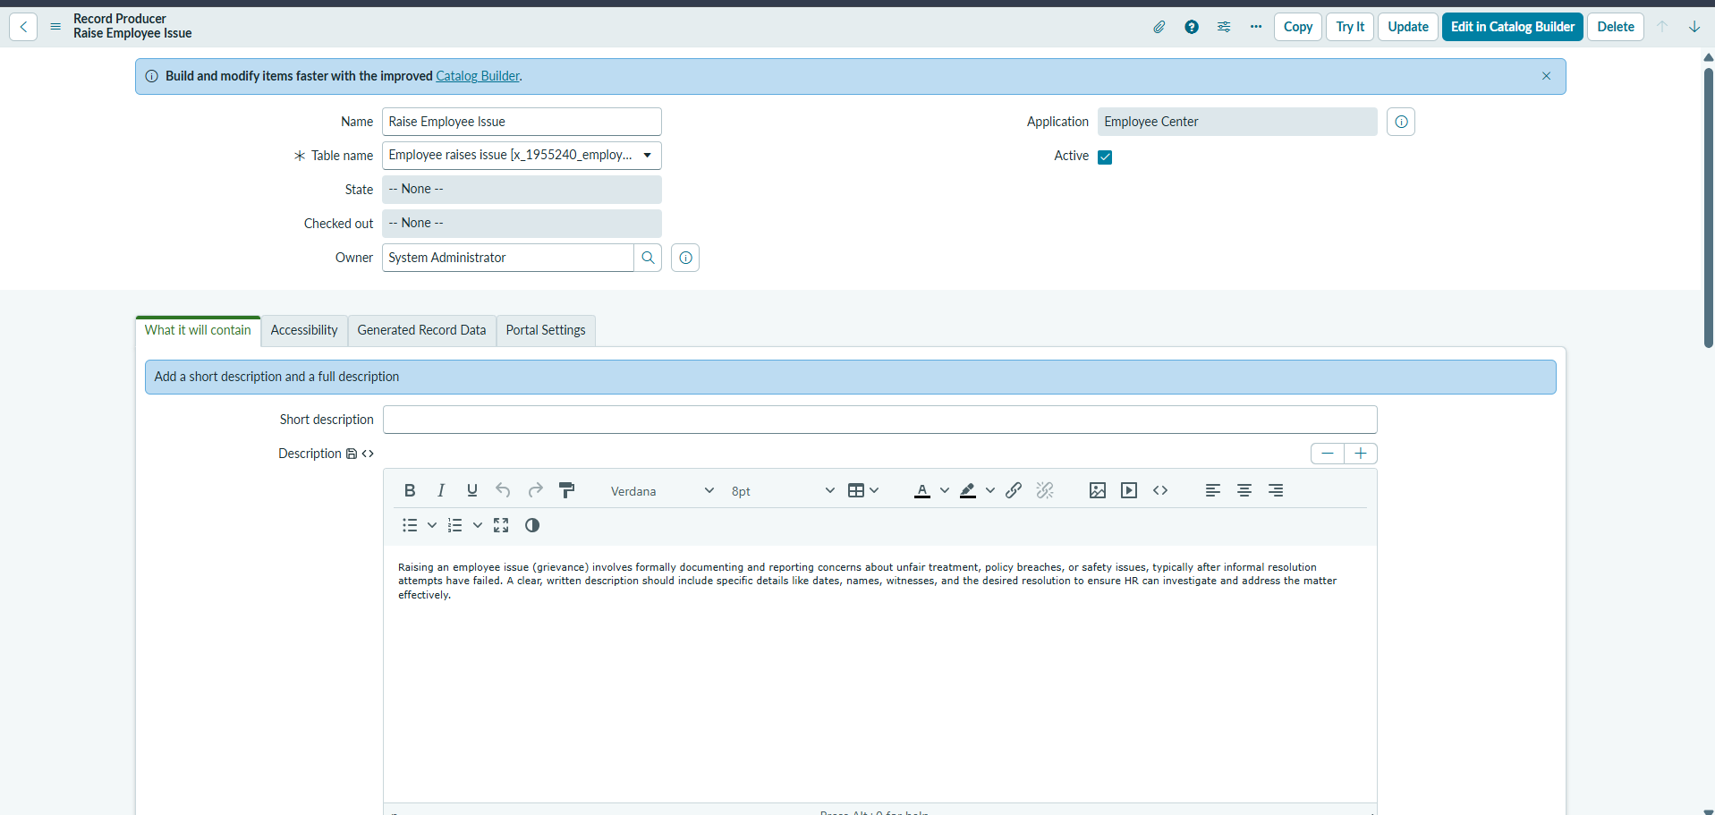

Variables list
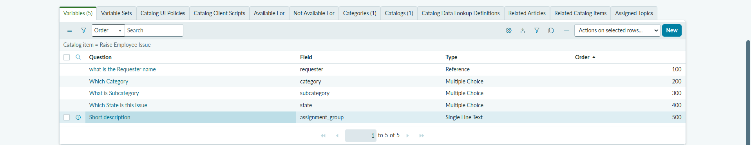
Individual variable mapped to field
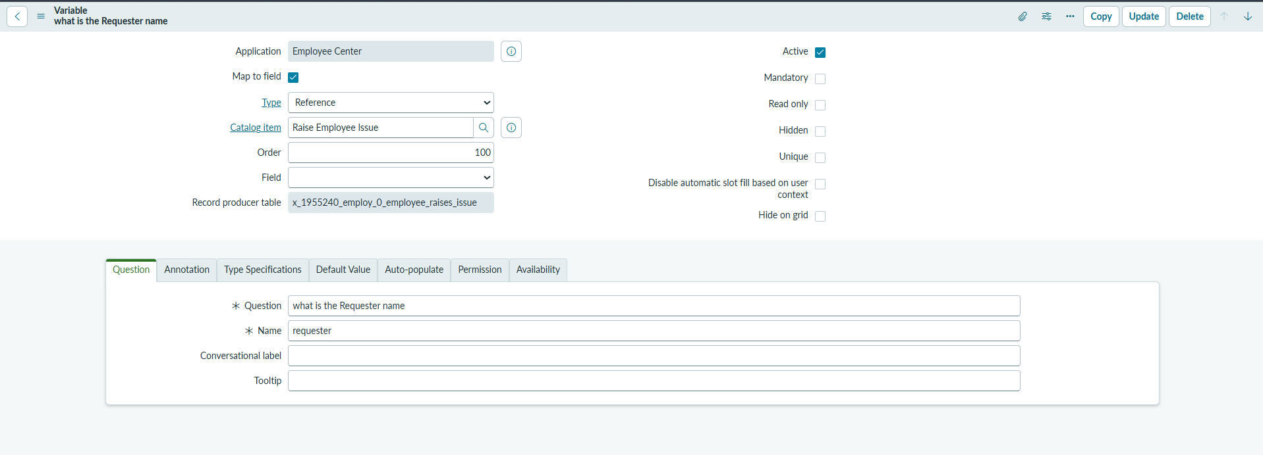
Record Producer on Service Portal
